Name: Shourya Desai AIDS-B Batch 2 Roll No. 4
ASSIGNMENT 3
Write a program using TCP socket for wired network for following:
a. Say Hello to Each other b. File transfer c. Calculator (Arithmetic)
d. Calculator (Trigonometry)

CODE:
Server Code:
import socket
import math

server_socket = socket.socket(socket.AF_INET, socket.SOCK_STREAM)

server_socket.bind(("localhost", 5000))

server_socket.listen(1)
print("Server is waiting for connection...")

conn, addr = server_socket.accept()
print("Connected with:", addr)

msg = conn.recv(1024).decode()
print("Client says:", msg)
conn.send("Hello Client".encode())

file = open("received.txt", "wb")
data = conn.recv(1024)
file.write(data)
file.close()
print("File received successfully")
conn.send("File received".encode())

data = conn.recv(1024).decode()
a, b, op = data.split()
a = float(a)
b = float(b)

if op == '+':
result = a + b
elif op == '-':
result = a - b
elif op == '*':
result = a * b
elif op == '/':
result = a / b

conn.send(str(result).encode())

data = conn.recv(1024).decode()
angle, func = data.split()
angle = float(angle)

if func == "sin":
result = math.sin(math.radians(angle))
elif func == "cos":
result = math.cos(math.radians(angle))
elif func == "tan":
result = math.tan(math.radians(angle))

conn.send(str(result).encode())

conn.close()
server_socket.close()

Client code:
import socket

client_socket = socket.socket(socket.AF_INET, socket.SOCK_STREAM)

client_socket.connect(("localhost", 5000))

client_socket.send("Hello Server".encode())
print(client_socket.recv(1024).decode())

file = open("send.txt", "rb")
client_socket.send(file.read())
file.close()
print(client_socket.recv(1024).decode())

client_socket.send("10 5 +".encode())
print("Arithmetic Result:", client_socket.recv(1024).decode())

client_socket.send("30 sin".encode())
print("Trigonometric Result:", client_socket.recv(1024).decode())

client_socket.close()

OUTPUT:
Server Output:
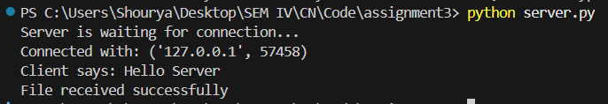

Client Output:
